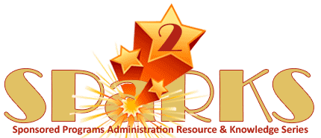

Module 12:
Audits & Investigations

November 6, 2013
Instructor: | Phone: | E-Mail:
Doug Backman | 407-882-1168 | Doug.Backman@ucf.edu

Module Description
An introduction and general overview of the types of audits and investigations.

Module Overview
The purpose of this module is to provide participants with a greater understanding of OMB Circular A-133 enabling them to apply the standards set forth relevant to audits and investigations requirements.

Module Objectives
- Participants will gain a greater understanding of the types of audits.
- Participants will understand the types of investigations.
- Participants will learn basic definitions, concepts, and related requirements.
- Participants will have a resource for applying OMB Circular A-133 guidance to job tasks.

